Lighting can make it look more round

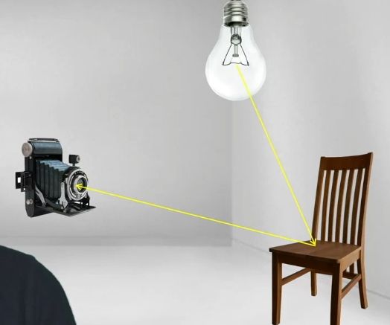

So a directional light doesn't have a position, it doesn't matter how near or far you are to the directional light. It just matters what direction it's facing relative to you.

Point light, it has a position, but it doesn't have a direction, like just flows in every direction from the light source. So here the lighting is really going to be influenced by how near or far you are from the light source. Good for lamp

Spotlight has a position and a direction and light only flows out in a certain cone. So, it's like a spotlight in the theater, it's it's quite a narrow focus light that only shows shines on a certain spot. Except that the further the light is away, the wider the area covers because it's a cone.

Ambient light is just a little bit of a hack to get around that, which is that you're just applying, like everywhere. You apply a certain amount of light to everything wherever it is, irrespective any in light source, it doesn't even have a position. So, it's a nice way of modeling those lights, it's not very realistic.

First -> Doesn’t reflect light

Second -> Diffuse material, light is bouncing off the object and then bounces in every direction.

Third -> spectacular illumination, much more direct illumination. So lighting coming off a mirror bounces off in exactly the same direction or sort of exactly the same angle at which it bounces back but in the opposite direction. And that means that you can actually see things in a mirror because it's so exact.

Last -> Color, color is an object only reflects certain wavelengths of light. So a blue object will actually absorb all the green and the red wavelengths and only reflect the blue objects as you can see in this example.

Point B has the light source almost right on top of it, which means the surface normal at point B almost overlap with light ray from that point. So point B receives a lot of light, but for point A, the light casting on a surface where A is is from a bigger angle. Or in other words, the surface normal A really points away from the light source, so A does not receive a lot of light.

where the intensity of the light at a certain point is proportional to the cosine value of the angle between the surface normal and a light ray.

For diffuse coefficient k_d, we know that as k_d increases, more lights are reflected. The same applies to k_s, the bigger the k_s is, the more lights an object reflects.

Because the maximum value of h dot n is one, this guarantee that the middle point is always highlighted, but as the point of interest shifts away from the center, where the pure specular effects applies, h dot n will be getting closer to zero, where the highlight vanishes. The higher m is, the more quickly this highlight effect vanishes, the smoother the highlight point is. The bigger m will give a more specular looking surface.

Diffused lighting doesn't depend on the viewer angle, though specular lighting will depend on the viewer angle.

return OUT

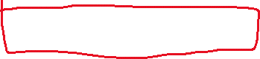

## Ambient light

Can get all the light then loop through the light

